1. Graphical user interface, text

   Description automatically generated
2. 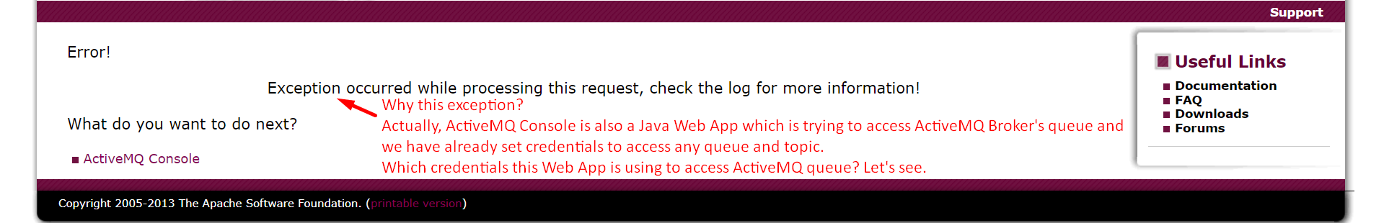
3. Graphical user interface, text, application

   Description automatically generated
4. Graphical user interface, application

   Description automatically generated
5. Rerun the Web Console App by running **bin/win64/activemq.bat**.
6. 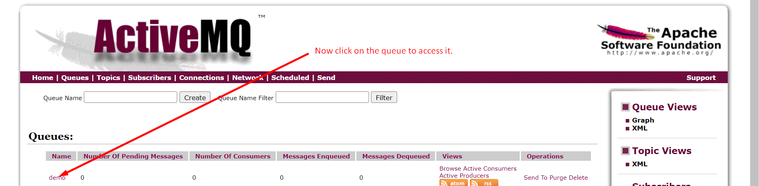
7. Graphical user interface, text, application

   Description automatically generated